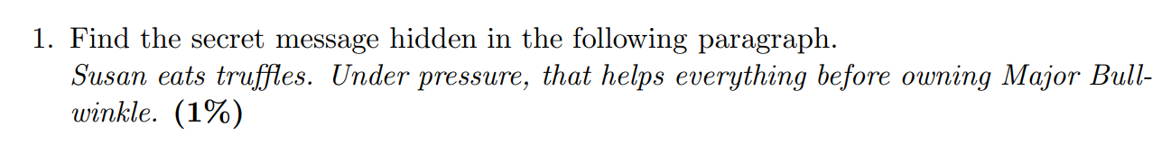  
SET UP THE BOMB

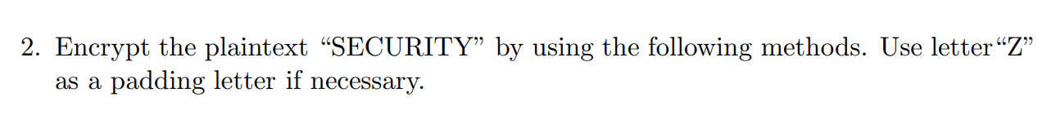

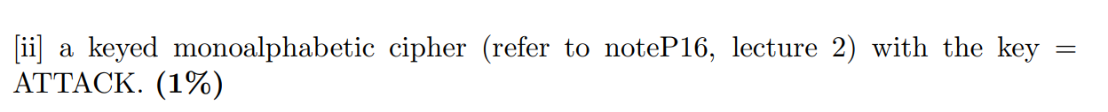

ABCDEFGHIJKLMNOPQRSTUVWXYZ - Start here

ATCKBDEFGHIJLMNOPQRSUVWXYZ

**CIPHER-TEXT**: RBCUQGSY



ABCDEF  
GHIJKL  
MNOPQR  
STUVWX  
YZ

ABCDEFGHIJKLMNOPQRSTUVWXYZ – START HERE  
AGMSYBHNTZCIOUDJPVEKQWFLRX

PLAIN-TEXT: SECURITY  
**CIPHER-TEXT**: EYMQVTKR